Joseph Goergen

Exercise 7.20

|  |  |
| --- | --- |
| Entity Set | Primary Key |
| Name | Address |
| Publisher | Name |
| Customer | Email |
| Shopping_basket | Basket_id |
| Book | ISBN |
| Warehouse | code |

a)

b)

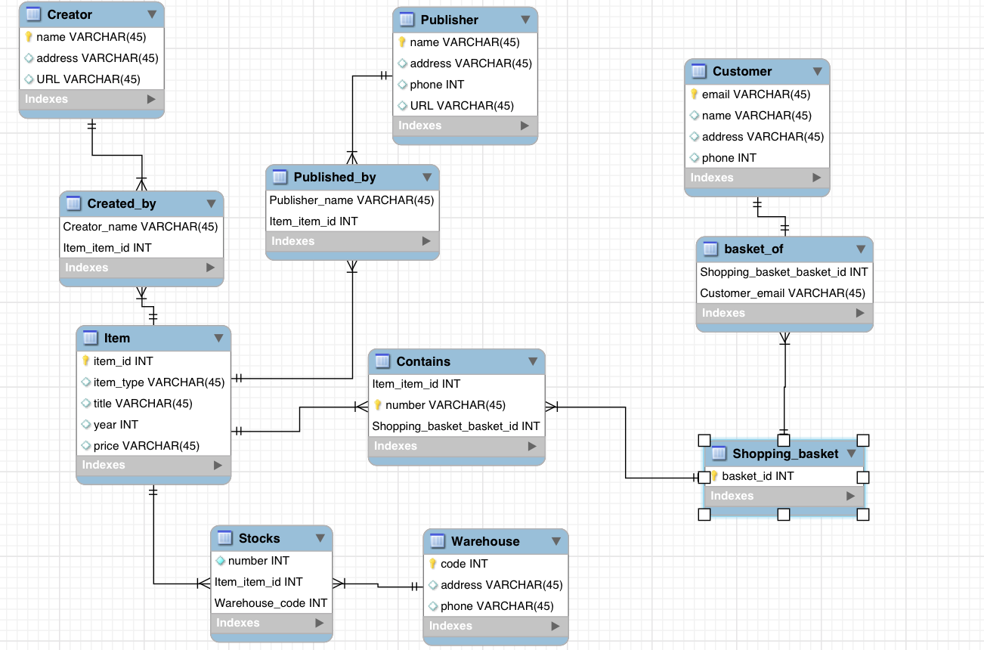

c)

